Specialist Vortex GT1 Gaming PC -£579.99
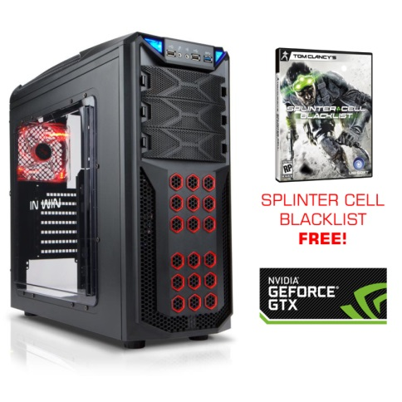
This pc is ‘packed full of the latest and greatest hardware so you can immerse yourself in your favorite games straight out of the box’. With its 2GB NVIDIA GeForce GTX 660 Graphics - DirectX 11 graphics card which is highly rated and recommended for pc gamers. A good graphics card is required if gamers want to play there games in high quality. A good graphics card will also be beneficial to the daughter who likes to edit videos as it will show the video in high quality and make it easier to edit. The very generous 8GB Kingston HyperX RAM, allows the user to do more things at once which is beneficial to a gamer but also very beneficial to the son of Mr and Mrs Smith who likes to edit videos as this may require many applications or documents to be open at once. The Intel Core i3-4130 operates at 3.40GHz which will allow the computer system to carry out the instructions of the program for instance the controls of the game very fast. Modern games these day and photography with the latest camera can take up a lot of storage space when save on your pc. Therefore the smith family will benefit from the pcs 1TB hard drive. To give a better idea of how large 1tb hard drive is, it can store approximately 357 DVD quality movie files on 1TB of storage or at the highest quality settings on a current general use camera the worst file size would be 1mb and with 1tb you’d be able to store over 1 million pictures. This gives an idea how much a 1tb hard drive can store and so will be beneficial to the family who will save many files on their pc and shows it will last them awhile without the instant need of an external hard drive.

Chillblast Fusion Axe Gaming PC - £386.14
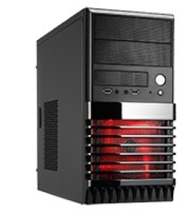
This Pc will be suitable for the family’s needs but doesn’t cost the earth. Its Intel Pentium G3220 Haswell Processor 3GHz will allow instructions to be carried out at a fast rate, for instance different controls that are used to edit videos will not be seen as slow and the gamer should not spend more time waiting for the game to load than on actual game play. The AMD Radeon 7730 Video Card paired with the 3GHz processor will allow high gaming and video quality and detail at a low price, in comparison to other gaming pcs which tend to be over a hundred pound more expensive. The 4GB RAM will also allow the user to have opened multiple applications at once and for the pc to still run smoothly. RAM will be an important factor to consider for the video editor of the family as she may be running different applications at once and have different windows open, therefore the more space the better.
The 500GB hard drive allows room for all the sons’ games as well as storage for the daughter’s videos and their edited version. For some of the latest PC games, they take up 2-6GB. For instance Assassins creed black, a fairly recent game, requires 4GB of space. Therefore it is possible to save around 100 games on this gaming pc. A 500GB harddrive can also hold up to 100,000 digital photos, up to 125,000 songs (MP3), up to 38 hours of Digital Video (DV), or up to 190 hours of DVD quality video. If the smith family feel they would quickly exceed the space provided by this Pc they may wish to go for a pc with a1tb hardrive or perhaps wait a while and eventually buy an external harddrive.

Zoostorm Haswell Desktop Pc - £599.99
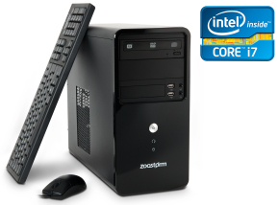
This PC has a whopping 2TB Harddrive. This PC will have the capability of holding around 800 games as many of the latest releases require around 4-6 GB of space, up to 304 hours of Digital Video (DV), or up to 1520 hours of DVD quality video. With this Pc the smith family are very unlikely to run out of space, even in years to come. This Pc has an Intel Core i7-4770 3.4ghz Haswell CPU, the same as the specialist vortex GT1 gaming pc. The CPU executes programs such as games stored on a computer. It takes in instructions and puts out data and for this pc at a fast rate with it operating at 3.4 GHz. This is beneficial as the latest games require a good up to date CPU, so the game performance isn’t poor and doesn’t lag. This is also the same for playing videos. The RAM in this pc is also very generous; in fact double the size of the RAM in the specialist vortex GT1 gaming pc being 8GB. Because video files are very large, you'll not only need a big hard drive to store the file, or a quick processor, but also lots of RAM to help speed things up. Ram will also be beneficial to the user if they tend to open several programs at the same time and switch between them frequently as it allows smoother multitasking. The On-board integrated Intel HD 4600 graphics on its own is not just needed for a great gaming experience, a large RAM will also be required to supports colour at higher resolutions and gives you crisper, brighter images and excitingly fast 3D video and animation for a powerful, virtually real gaming experience.

To conclude the specialist GT1 Gaming PC will be most suitable for the needs of the family. Although it hasn’t got as big a harddrive as the zoostorm hardwell desktop PC, this shouldn’t be a problem as 1TB should be more than enough to save games and edited videos which will take up a lot of space, due to how detail and the quality of edited video making the file size bigger and the detail which is expected from a recent pc game.
It also has a CPU which is better than the Chillblast Fusion Axe Gaming and the same as the Zoostorm Haswell Desktop Pc .Processor speed will be a great concern for the Smith family as the son prefers to play modern 3D games. For this type of gamer, 2.0 GHz could be thought of as a good "baseline" processor speed, so 3.4 GHz will definitely provide game performance with no lag. The Specialist Vortex GT1 Gaming PC also has dedicated graphics meaning it is not built into the motherboard and can be swapped for another graphics card in the future, which is beneficial as games are predictably going to evolve even more, become higher quality and need a even mc ore powerful graphics card.

