Software Utilities
What is a software Utility?
Software utilities are software programs that add functionality to your computer or help your computer perform better, but are not necessarily needed for the computer itself to function.
Some utility programs help keep your computer free from unwanted software such as viruses and spyware, other types of software utility add functionality to the computer which allows you to customize your desktop and user interface.

Security (Antivirus, firewalls)
Virus protection can prevent a pc being attacked by viruses (program designed to erase data and corrupt files), worms (can forward virus through email to all contacts) and Trojans (hides by presenting itself as a harmless file).
Antivirus software spots intruders. It tries to trace viruses by spotting the virus signature. Therefore virus writers invent new viruses and design them so they change in appearance, size and have a different signature each time it infects another pc in an attempt to make anti virus software to spot it. However almost as soon as a new virus is written antivirus traces these new viruses and adds them to the database of information of viruses such as profiles and signatures of the virus. Updates are then made available to the users to block harmful viruses getting into their Pc. Some users either automatically or the user will be sent an email that an update is available.
The main defence against viruses is to subscribe to a reliable form of anti virus software, examples include McAfee and Norton. These perform regular scans, show harmful websites when using search engines, will block you from opening links or files which could damage your pc and delete the virus before it does any harm and stops the PC’s ability working at its full potential.
Firewalls are also a form of security. A firewall isn’t the same thing as anti-virus program, but to help protect your pc you need both a firewall and an antivirus program. Firewalls build a protective barrier around computers so that only authorised programs can access data on your pc. Firewalls work by checking information coming from the internet or a network and either blocks it or pass it through depending on whether it is safe and your firewall settings. A firewall can therefor prevent hackers or malicious software gaining access to your computer.

Distinct market leaders include Mcafee and Norton antivirus. On the website Norton antivirus says it Keeps you safe when you surf, shop and bank online, Protects you from social media scams, Stops both today's and tomorrow's online threats and Blocks infected and dangerous downloads. I as a Norton anti-virus user myself know it performs daily big scans and small scans every hour or so to do all the things mentioned before. Mcafee offers different types of protection for different computer users for instance, for consumers at home, enterprise and small business aswell as partners. Mcafee like Norton also Silently installs and updates in the background and does not interrupt productivity. It also Alerts direct customer to McAfee offerings if antivirus software, firewall protection or web security is out-of-date or not found. Instant security status also lets user know if their computer is at risk and recommends solutions to solve security issues in seconds.

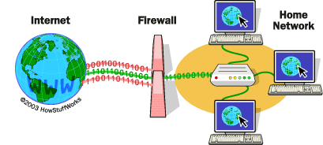

Clean Up Tools (Cookies, history, defrag)
Clean up tools remove the clutter of data your pc collects over a period of time. Clean up tools can be used to solve the clutter problem. Disk Clean up scans files and lists all of the files you might like to delete. For instance Clean up tools can remove cookies.
Cookies are left on your computer when you have registered details such as address and payment details when purchasing a product online or signed up for a subscription of a newsletter for instance. A cookie is left so that the site can recognise you the next time you visit and to save the user time entering your details again. However there may be cookies from sites you only enter once and so might find you would rather remove them from your system to speed up your system and make space.
Like cookies, Internet history makes it easier and quicker for the user. It is noticeable that when you use the Back and Forward buttons, the web page loads quickly because it does not need to be downloaded afresh. Each time you request a page on the Internet, a copy of that page is retained in the Temporary Internet Files folder. This is useful but the space taken up by these pages can accumulate to a large amount. Therefore it is useful for the clean up tool to free space by deleting pages from the temporary internet files.

Each time you save a file, the space on your hard disk begins to fill. When files
are deleted, some space becomes available, however sometimes when a file you want to save will not fit into the space made available also known as ‘gaps’. The system copes with this by fragmenting the file and storing the fragments wherever it can. Meanwhile additional space is taken up in the process noting the whereabouts of the fragment and the files on the disk become unorganised. Defragmenter rearranges files so that the gaps created are used up systematically, leaving available space.
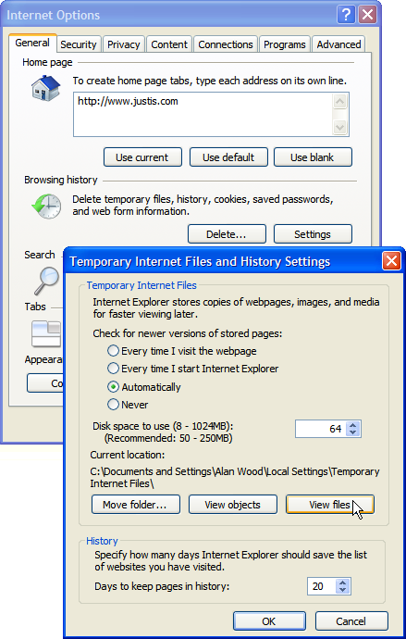
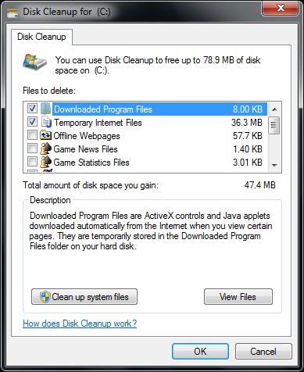
Here is the windows disk clean up. It is very simple to use and the Disk Clean-up utility removes unnecessary files to free up space on the disk drive of your choice. It shows how much space in MB you free up which will change as you tick or untick files. The disk clean-up will remove temporary internet files such as internet history and cookies. The Internet Explorer 7 browser allows you to locate and delete cookies from a particular website.

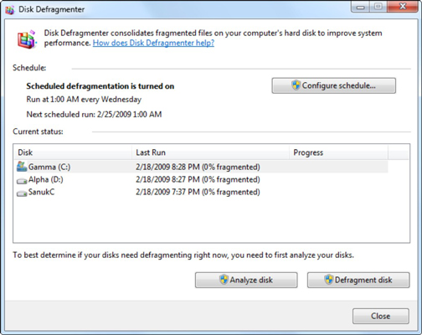
Defragmenting a hard drive with Windows 7 is very simple. By default, Windows 7 automatically schedules a disk defragmentation session to run every week. Hard drives would get increasingly cluttered with random bits of files that were scattered all over the surface of the drive causing a number of problems if disk defragment didn’t happen, so it is therefore very important.
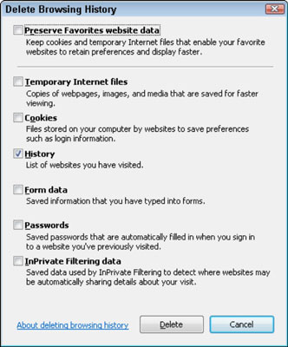

All web browser programs come with a History feature. It details the websites and pages you visited for the past week or two. That way, you can quickly return to where you once were. Sometimes it may not be necessary for your computer to store these details and you may rather free up space.

Drive formatting
Storage media has to be initialised or ‘formatted’ so the storage media can be recognised by your computer and be used to store data files. Physical (low-level) formatting tests the surface, scanning for imperfections and setting aside those sectors that cannot be used. Whereas Logical (high-level) formatting prepares the disk by setting up a file system which then defines how files and folders will be stored and accessed. The high-level formatting process writes material to allow the operating system to interact with the disk. This includes the boot sector which holds data about how data is organised on the disk, such as the number of sectors, the number of sectors per track and the number of bytes per sector. Also the root directory table which has an entry for each file on the disk:
the name of the file and the file extension, the file like the date and time that the file was created or last updated and the length of the file.

3rd Party ( Anti-spyware)
Anything which isn’t under the brackets of drive formatting and clean up tools
e.g file namer, file organiser, burning software. An advantage of 3rd party software is that it is often cheaper or even free as the software is not supplied by big companys such as Microsoft and more functions may be provided in comparison to what apple os software may offer. A disadvantage of third party software is security issues as can allow unauthorised access to your pc in which the users files and data is accessed.

Who might use them?
Software utilities can be used by anyone with a computer. For instance many people including myself, use clean up tools to remove the clutter of data the pc collects from cookies and internet history for example. Some software utilities are mainly used by advanced computer users for instance drive formatting as they may want to clear the harddrive and use it for something completely different.

How do they benefit a user/computer?
- With the help of disk defragmenter, it is possible to bring all the fragments at one location and raise efficiency of working.
- Disk cleaners detect unwanted files and delete them to free users space such as cookies and web history.
- Virus scanners also known as anti virus software helps protect useful and important files on the computer by detecting them.
- Firewalls block malicious software gaining access to your computer and getting control of important files.
Disadvantages of using software utilities?
- A disadvantage of utility software in your computer is related to speed. Too many utility programs eat up the memory and the RAM and will slow your computer down significantly.
- Another disadvantage is reliability. If a utility computing company is in financial trouble or has frequent equipment problems, clients could get cut off from the services for which they're paying.
- Utility computing systems can also be attractive targets for hackers. A hacker might want to access services without paying for them or snoop around and investigate client files.
- Software utilities are not free, and are costly.

