Date, Time and Region check
I am going to use the Control Panel to check date time and region. I will open control panel in the startup menu, open it and go to "Clock, Language, and Region". I will do this test to make sure date time and region is correct as having this wrong information may affect the times in which updates install or cause software to conflict, and it may cause problems for the user if they rely on correct date and time from the pc. For instance when writing a letter they may perhaps look at task bar and use the date they see, this will be a problem If the date is wrong, it is therefore important to check the information is correct. I will test the dates are correct by comparing the time and date set on the pc with the time and date on the internet as internet time and date will be accurate. After comparing the two I found the date and time matched and therefor is correct. I should perform this test every so often especially after time change or if I were to enter a different time zone if I go to a different country.
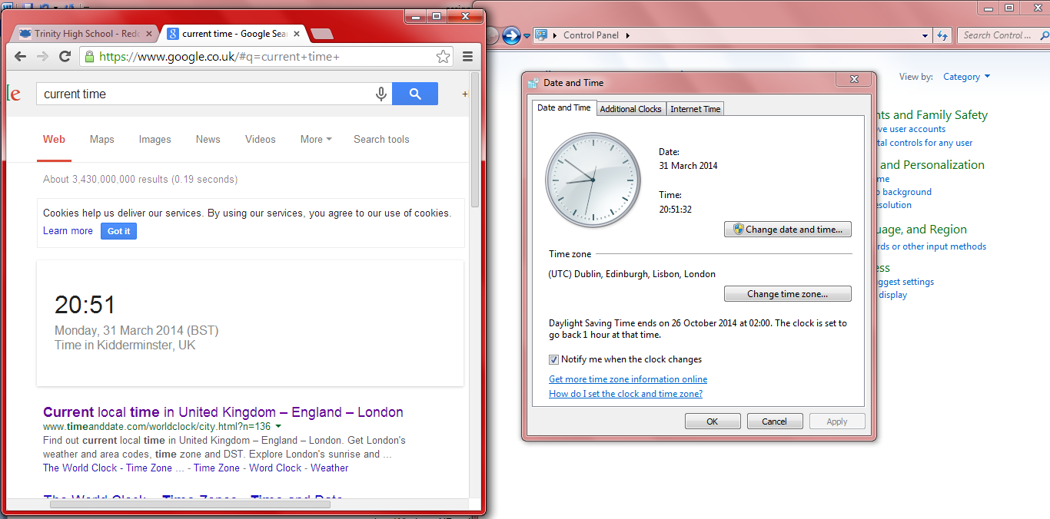

Boot time
I will perform a boot time test to see how long it takes for my computer to get to the log on screen. I will test this by shutting down my laptop and starting it up again and repeat these 3 times to get an average.
Test 1 – 3.2 mins, Test 2 – 2.8 mins, Test 3 – 2.6 mins, Average 2.7 mins
I found my computer boot time in comparison to other pcs simply dragged. Waiting lengthy periods for my computer to start every day has seriously impacted my patience and schedule as I like to turn on my laptop and get to work right away. Performing regular hard drive maintenance on computer every few months will reduce boot time. I could run disk defrag or disk clean-up to remove not needed files. The user could also remove old programs as over time, we have a tendency to accumulate programs that we don't need or use. The user could also Update or install anti-virus software as outdated anti-virus software can miss new viruses that may get downloaded to your system. These viruses can cause your system to boot slowly. Another method is to switch your operating system. Certain operating systems take longer to boot. For example, Windows Vista takes longer than Windows XP to boot up.

Speed of broadband
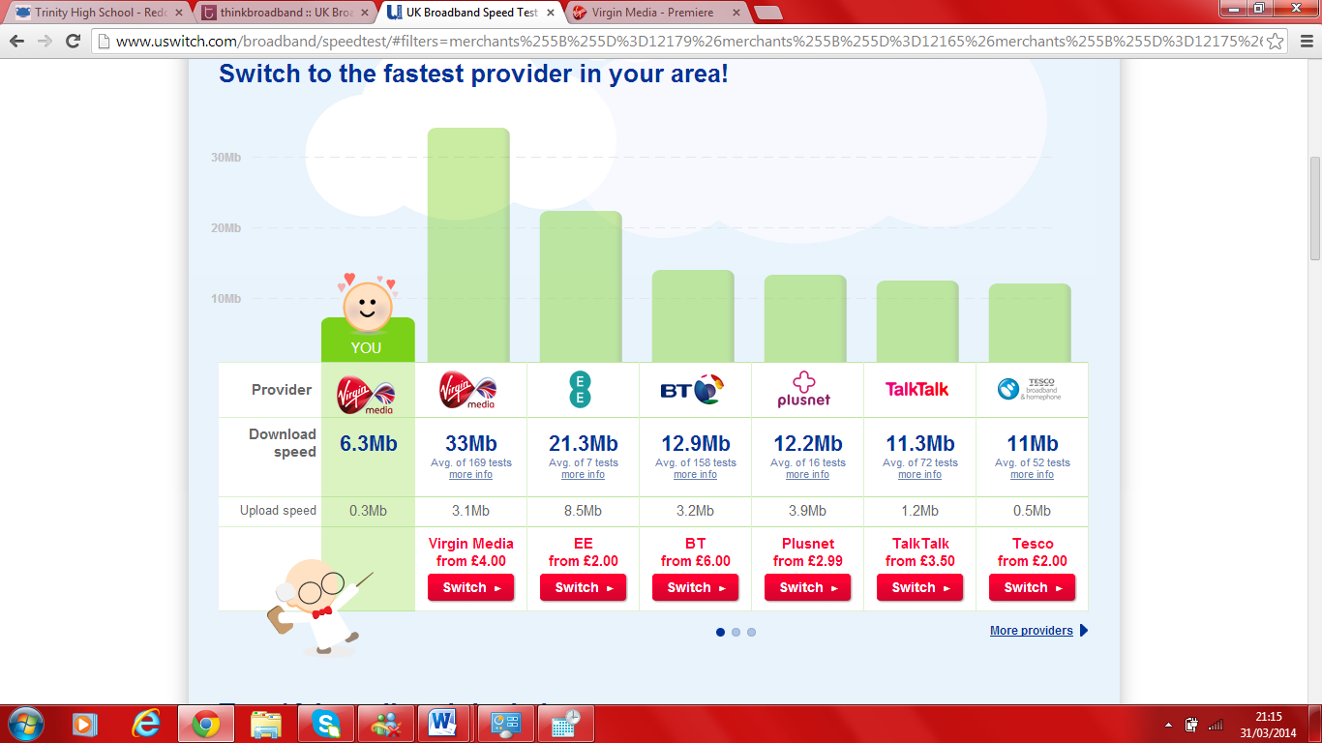
I will be testing my speed of broadband by using an online speed test and comparing this to the max speed of my broadband package. The results show my laptops download speed is 6.3mb and upload speed is 0.3 mb. This is much lower than the average for the virgin media supplier, and lower than the maximum for my broadband package which is 100 mb. I could improve the speed of broadband by getting a better router so wifi connection is better and download and upload rate is higher and ping rate is lower. I could also take unnecessary device off of the wifi connection as having many devices connected to a router will affect the download and upload rate of the laptop. If wifi connection is still a big problem I could have a wired connection to the router as wireless isn’t as good in comparison and the speed of broadband won’t be as good.

Graphics test
I carried out a performance check to check the graphics of my computer and test my graphics card against others. I found the 3D and 2D graphics was very low in comparison to others, however this was not surprising as my PC wasn’t bought for the intention of gaming for instance and my graphics card is dedicated, which relies heavily on good graphics, my graphics card is only suitable for day to day tasks such as internet browsing and word processing for instance. However if I decided to start playing games on my pc, or conduct photo/video editing it would be a good to upgrade my graphics card to dedicated as dedicated graphics card has its own built-in memory, thus reducing the demand on the computer’s internal memory and also will support colour at high resolution and gives you crisper, brighter images and excitingly fast 3D video and animation for a powerful, virtually real gaming experience and detail needed for successful video/image editing.

CPU
I used the ‘performance test’ software to test the CPU of my PC, against other CPU’s. From the test I found my CPU doesn’t perform as well as others but performs nearly as well as the intel core 2 processor. Having an up to date fast CPU is important as the faster the processer the better your computer can run multiple tasks. The fact the results show my CPU doesn’t run as fast as others shows my computer doesn’t carry out instructions and run process tasks as fast as it potentially could. A way to improve the speed that the CPU carries out the instructions of a computer program, is to upgrade your CPU so it has a bigger memory and is faster (maximum 3 Ghz, 2.1ghz being the lowest speed).

